Ex.No: 7a | DATA VISUALIZATION USING TABLEAU

AIM:
To connect, analyze, visualize, and create interactive dashboards using Tableau for effective business intelligence and data analytics.

ALGORITHM 1:
Connecting Data Source
Step 1 Open Tableau Desktop
Step 2 Select Connect
Step 3 Choose Excel File
Step 4 Browse Dataset
Step 5 Open Dataset
Step 6 Verify Imported Data

ALGORITHM 2:
Creating Worksheet
Step 1 Open Sheet 1
Step 2 Drag Department to Columns
Step 3 Drag Marks to Rows
Step 4 Select Visualization
Step 5 Analyze Results

OUTPUT:
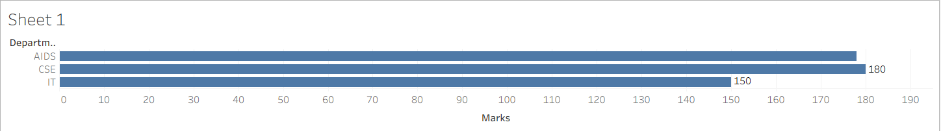

ALGORITHM 3:
Bar Chart Creation
Step 1 Drag Student → Columns
Step 2 Drag Marks → Rows
Step 3 Select Bar Chart
Step 4 Apply Labels
Step 5 Format Visualization

OUTPUT:
ALGORITHM 4:
Pie Chart Creation
Step 1 Drag Department
Step 2 Drag Marks
Step 3 Select Pie Chart
Step 4 Show Labels
Step 5 Analyze Distribution

OUTPUT:
Department-wise Marks Contribution
Contribution of departments to total marks.

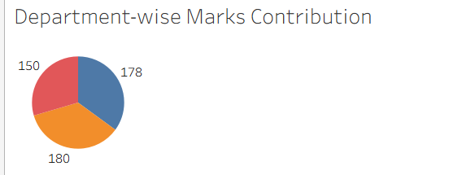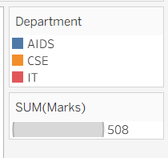

ALGORITHM 5:
Line Chart Creation
Step 1 Drag Student
Step 2 Drag Marks
Step 3 Select Line Chart
Step 4 Apply Formatting

OUTPUT:
Student Performance Trend
Marks trend among students.
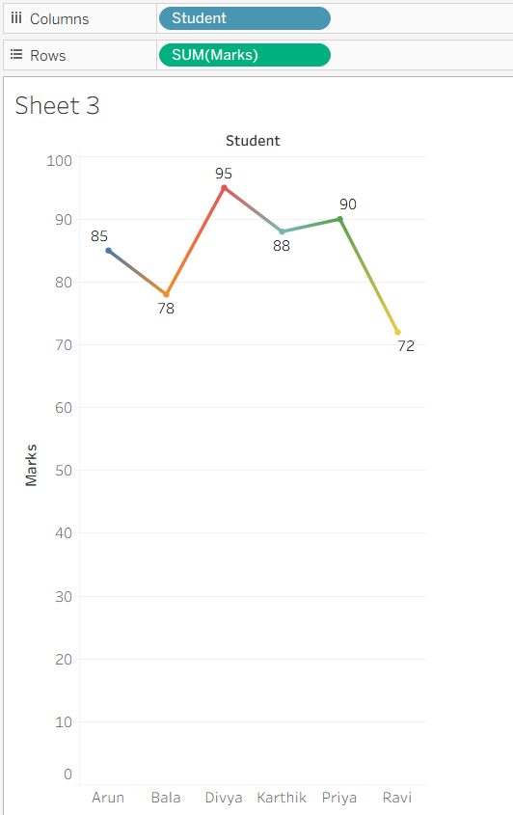

ALGORITHM 6:
Creating Calculated Field
Objective
Calculate Percentage
Marks Formula (Marks / 100) * 100

PROCEDURE:
Analysis → Create Calculated Field
Name: Percentage
Formula: [Marks]

OUTPUT:
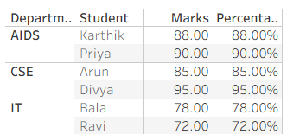

ALGORITHM 7:
Applying Filters
Step 1 Drag Department to Filters
Step 2 Select Department
Step 3 Apply Filter
Step 4 Observe Updated Charts

ALGORITHM 8:
Creating Parameter
Step 1 Create Parameter
Step 2 Specify Minimum Marks
Step 3 Apply Parameter
Step 4 Display Matching Records

OUTPUT:
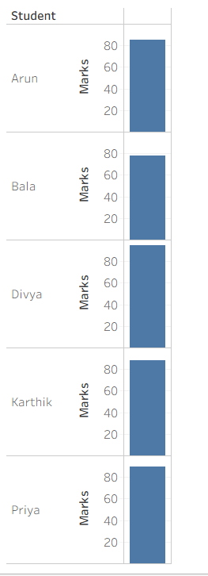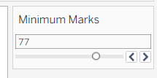

ALGORITHM 9:
Dashboard Creation
Step 1 Create Multiple Worksheets
Step 2 Select Dashboard
Step 3 Drag Worksheets
Step 4 Arrange Components
Step 5 Add Filters
Step 6 Save Dashboard

OUTPUT:
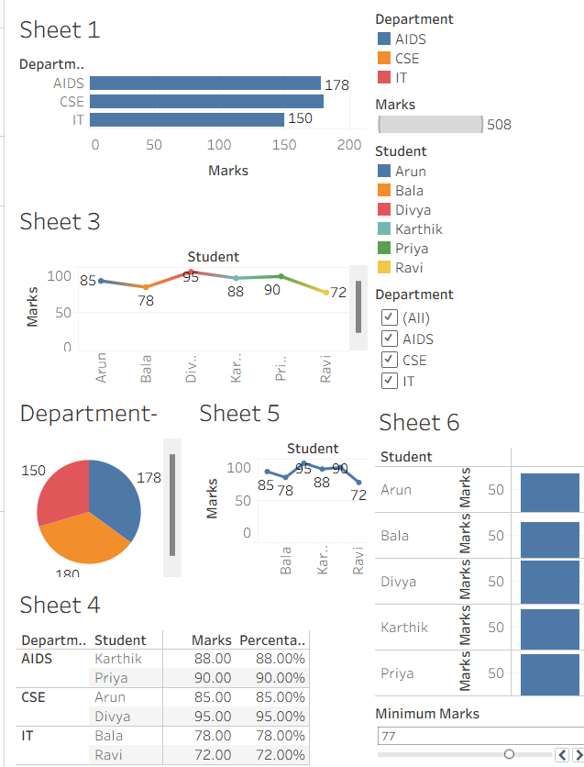

RESULT:
Thus, Tableau was used successfully to connect datasets, create worksheets, apply filters and parameters, generate visualizations, build dashboards, and create stories for business intelligence and analytical decision-making.

